Computer Networks
Assignment 2

2020-21
Even Semester

Submitted By:
Abhishek Kumar
19ucs241
Lab Batch: C4
1) What is the difference between HTTP and HTTPS?
HTTP stands for Hypertext Transfer Protocol.
HTTPS stands for Secured Hypertext Transfer Protocol.
The HTTP is transporting information over www without any security layer, and HTTPS is transporting information with the layer of security and encryption called an SSL Certificate.
In Computer Networking, HTTP works on Port 80 and HTTPS work on Port 443.

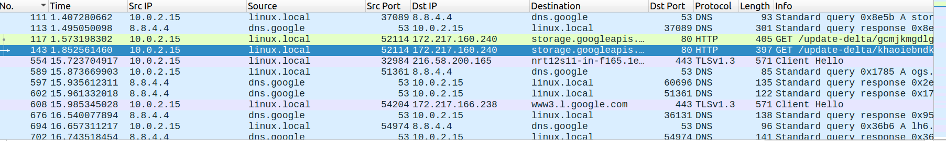

2) How is the differentiation between HTTP and HTTPS has impacted the result for the scenarios implemented?

In case of HTTP, we could easily see the email and password on POST request. While in the case of HTTPS, as data is encrypted so we can’t get essential information, making it secure.

3) What is your plain text message HTTP POST message information for all the websites you have worked upon?

For http://techpanda.org

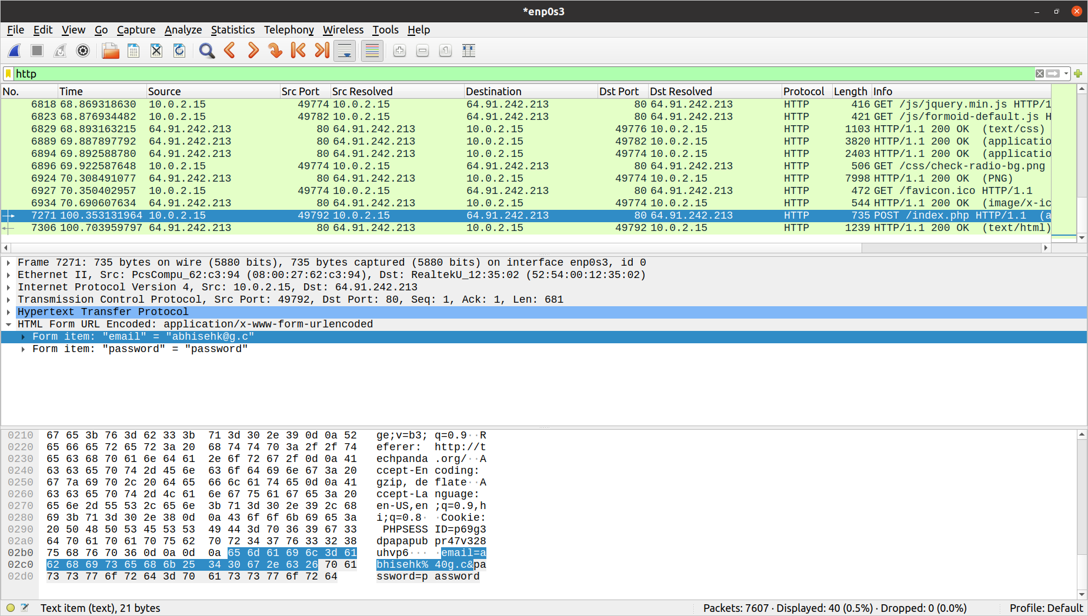

While the HTTPS POST messages can’t be sniffed, thus we won’t be able to sniff POST messages for Gmail and Facebook. (Screenshots attached below)

4) Could you sniff the credential information for all the websites? (Yes/No) Give reasons with substantiated result screenshot.

No, we couldn’t sniff the credential information for Gmail and Facebook because they use HTTPS and get their data encrypted.

For mail.google.com

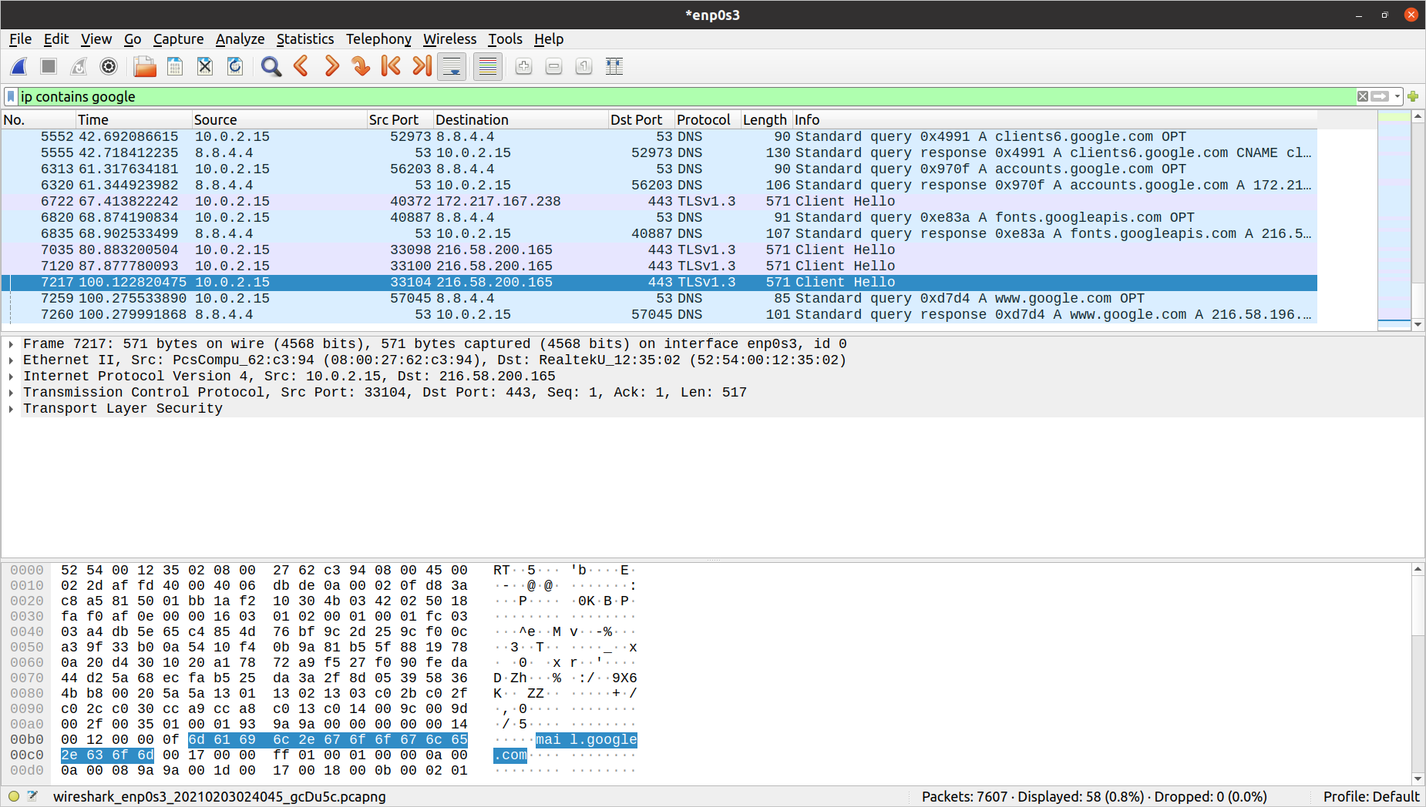

For www.facebook.com

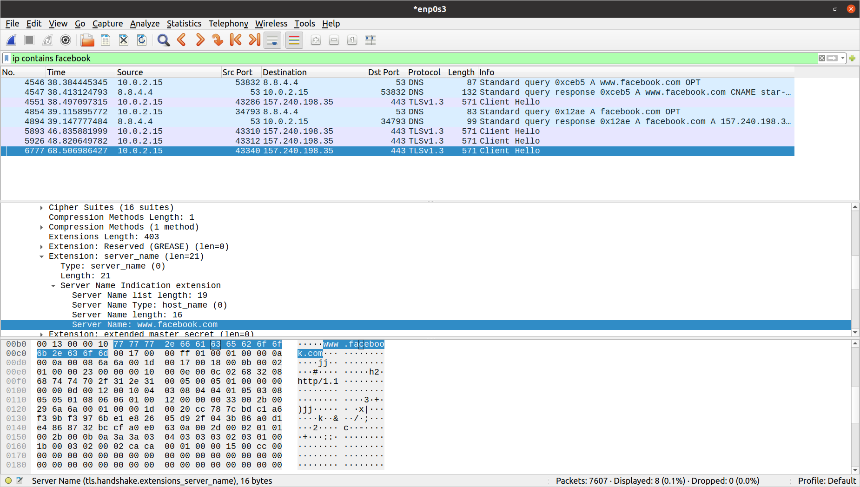

5) Name all the protocols which you have encountered during the sniffing operation. Explain their functionalities.

i) DNS
DNS stands for Domain Name System. DNS servers translate a human-friendly name, like “example.com”, to a machine-friendly IP address, like 192.168.2.1.

ii) TLS
TLS stands for Transport Layer Security. It encrypts the data sent over the Internet to ensure data security.

iii) TCP
TCP (Transmission Control Protocol) is a standard that defines how to establish and maintain a network conversation through which application programs can exchange data.

iv) IP
The Internet Protocol is the protocol which pretty much dictates how data(in form of datagrams) is transmitted to and from the internet.

v) UDP
Universal Datagram Protocol provides a connectionless service and without error recovery. It uses no acknowledgement, not resequence the messages and sets up no flow control.

vi) HTTP
HTTP: A client-server protocol which allows the fetching of resources and data exchange on the Web such as HTML.

(Screenshots attached below)

